**Define the data set being used for analysis: Identify where your data set comes from, its structure, and how it relates to security**

Where it Comes From

This is part of the suite of network analysis provided by AT&T Cyber Security. They provide timely data, driven by advanced analytics, that identify malignant and benign IP addresses.

Data Structure

|  |  |  |
| --- | --- | --- |
| Column Name | Variable Type | Description |
| IP | String | dotted-quad | The IP address. |
| Reliability | Integer (ordinal) | This is a measure of the reliability of the risk score. It is based upon the number of reports received on the IP address, with the more reports resulting in a higher reliability score. |
| Risk | Integer (ordinal) | A measure of the risk of the IP address |
| Type | String (categorical) | This captures the type of node making the request, ranging from no threat scanning host types, to |
| Country | String (categorical) | This is the country from which the IP address is sourced |
| Locale | String | Area within the country, typically a city. |
| Coords | String | This represents the longitude and latitude at which the IP address is located. This information forms the basis of |
| X | Integer (ordinal) | A secondary measure of threat, were higher scores represent greater threat. Derived from a combination of Risk and Reliability scores. |

How it Relates to Security

This data represents a proactive approach to cyber security. Allowing us to identify malicious IP addresses and preventing them from imposing costly damage.

Specifically, it offers a multitude of parameters upon which we can evaluate the threat of an IP address. Firstly, the type classification, whilst consisting of _ broad categories, can be appropriately reclassified into threat and non threat IP addresses. This classification can be made based upon whether or not the IP address is a scanning host (non threat) or of another type (threat).

This dataset offers three further dimensions of gauging the threat of an IP address in the form of three numeric variables, Reliability, Risk and X score. The benefit of this open access dataset is that it allows the user to craft their own metrics to quantify the threat of an IP address. Hypothetically, a weighted average of all three metrics could be used, and if this surpasses a user defined threshold, preventative denial of access requests from this IP address could be taken.

**Initial Observations: Detail your first exploration of the data. What steps did you take? Is there anything which is of particular interest? Is there anything which is unexpected?**

The data was downloaded in the form of .data file, with values separated by ‘#’. Utilising pandas read_csv() method, the data was imported and the appropriate headers were given.

Unexpectantly, 834 out of a total of 285,626 observations were missing X values. As this represents an insignificant proportion of the overall sample (0.3%), these were converted to 0 and should not detract from the analysis.

For the purpose of subsequent analysis, the following modifications were made to the data:

* Country dummy variables were added for each IP Address, for instance, a “1” in the “Country_CA” column indicates that the IP address is based in Canada, and a “0” suggests that it is based elsewhere. This data will be employed in a regression based analysis discussed later.
* The “Coords” column was split and segregated into a longitude and latitude column. This is done in order to assist with the construction of geographical maps.

Figure 2.1: Descriptive Statistics for Numerical Variables

|  |  |  |  |
| --- | --- | --- | --- |
|  | **Reliability** | **Risk** | **X** |
| **count** | 258626 | 258626 | 258626 |
| **mean** | 2.79804 | 2.221362 | 10.56078 |
| **std** | 1.130419 | 0.531571 | 1.62223 |
| **min** | 1 | 1 | 0 |
| **25%** | 2 | 2 | 11 |
| **50%** | 2 | 2 | 11 |
| **75%** | 4 | 2 | 11 |
| **max** | 10 | 7 | 12 |

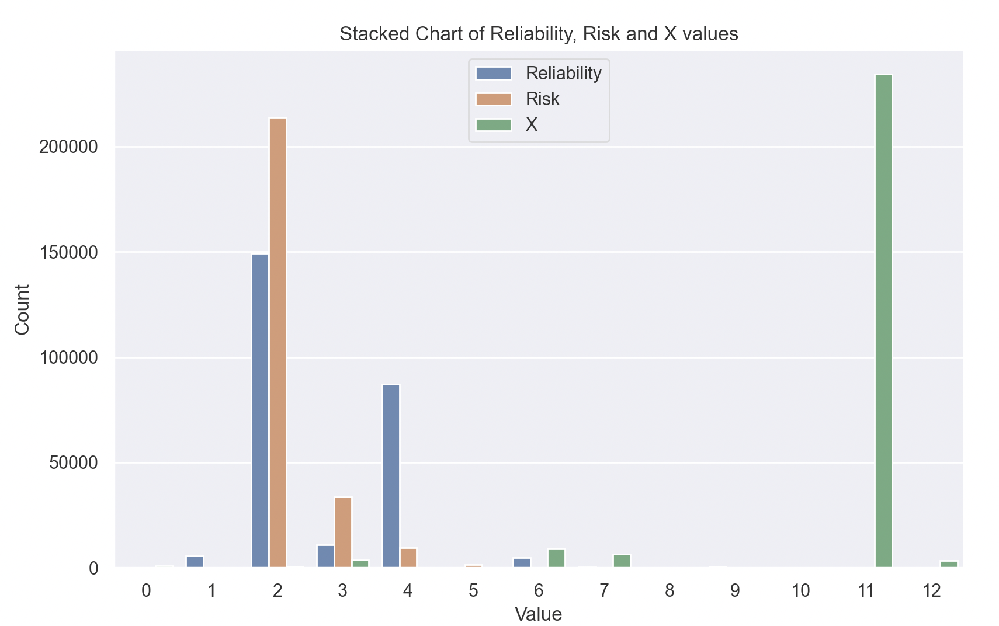

Both the mean of Reliability and Risk exceed the median value, suggesting the data has a positive right skew. Conversely, the opposite is observed for the X variable. Across all 3 variables, the low standard deviation scores indicate that there is not much variance within these categories. It is possible that most IP addresses are generally regarded as safe (given all scores are clustered around low values of their respective scales). Whilst this represents a positive outlook on the threat of cyber security, this lack of variation may thwart any meaningful analysis that looks to identify the drivers of Risk, Reliability and X scores.

Figure 2.2: Descriptive Statistics for Categorical Variables

|  |  |  |
| --- | --- | --- |
|  | **IP Type** | **Country** |
| **count** | 258626 | 258626 |
| **unique** | 34 | 152 |
| **top** | Scanning Host | CN |
| **frequency** | 234180 | 68583 |

Encouragingly, IP Type’s appear to be dominated by ‘Scanning Host’, considered to be a non-malignant IP Address. Indeed this category captures 90.54% of all IP addresses, with the remaining 9.46% captured amongst the remaining 33 categories. Country, on the other hand, appears to be less concentrated, with the most frequently appearing country being China, with 27.59% of observations coming from there. For a fuller breakdown of these two categories and the proportions in which they appear in the dataset, please refer to appendix A.

**Question: Identify a particular question to direct your analysis in more depth. Justify your question choice.**

I looked to exploit the rich variation in country to ascertain whether the probability of being a malicious IP address was dependent on its location. Firstly, such knowledge would serve well in handling incoming requests where the location is known, with high-risk areas instantly handled with greater caution. Secondly, if a correlation exists, this provides international drive to harmonize and reinforce more stringent penalties for attacks in cyber space.

Figure 3.1 Bar Chart Showing Count of Top 10 Countries

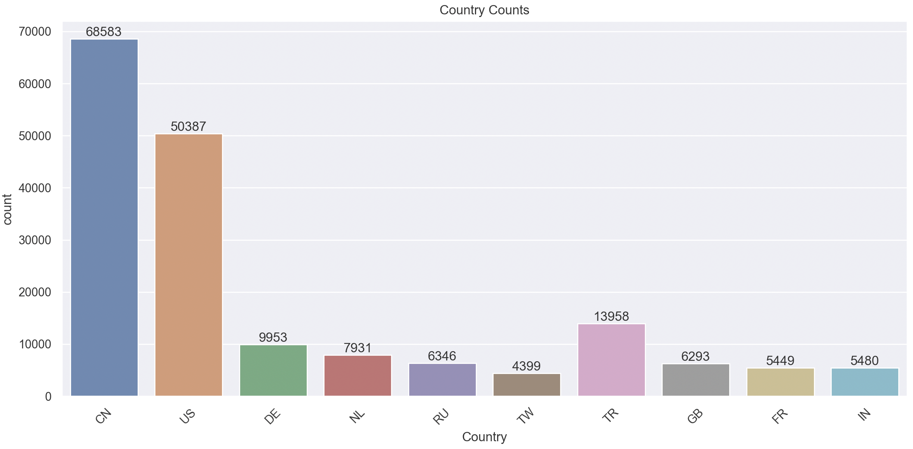

The dataset aptly offers detail on the country from where the IP address is located. From this graphic, we see an overwhelming proportion of the data comes from the US and China, with 27.59% and 19.48% of observations originating from there. To help put this in perspective, only 2.43% of observations come from the UK.

Figure 3.2 Bar Chart Showing Count of Top 10 IP Types

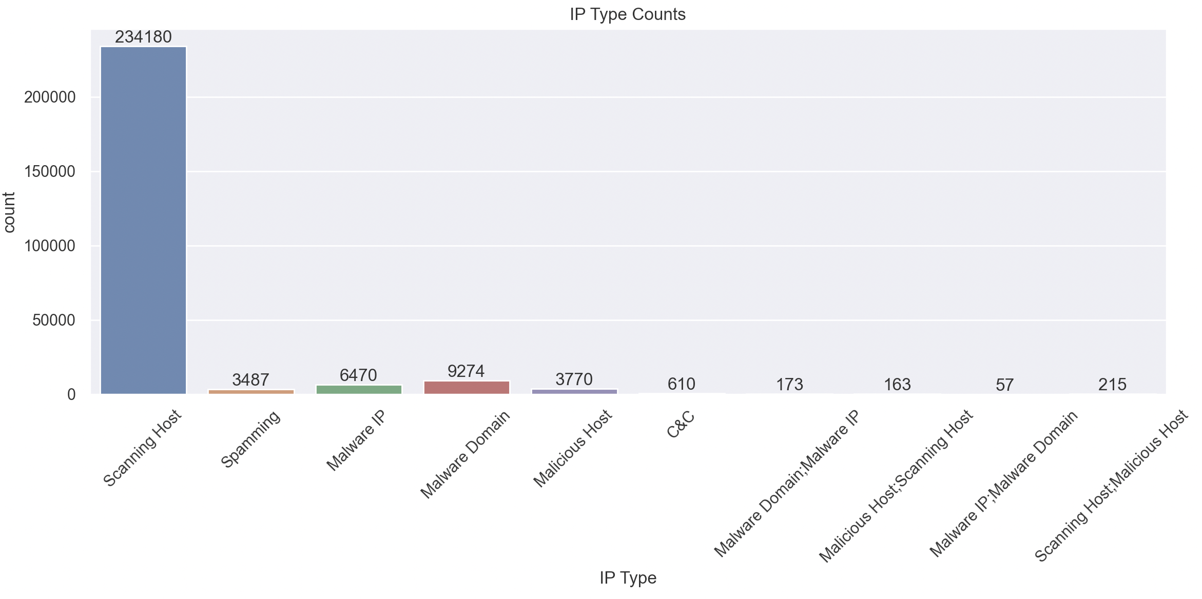

Even after removing the 24 least infrequent IP Types, it is visually reinforced that the vast majority of IP Type are indeed of type “Scanning Host”. Malware Domain, sitting in second place, classifies only 3.5% of obs.

Figure 3.3 Scatter Graph Showing Mean Risk and Mean Reliability by Country

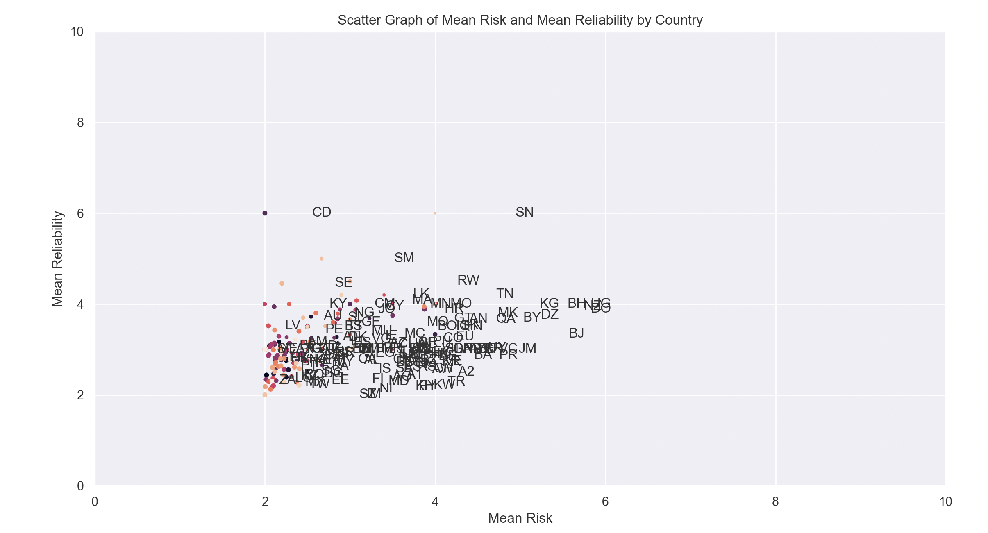

In this scatter plot I group by country then plot mean reliability against mean risk, with the size of the point reflecting the X score. Specifically, higher X scores are reflected in larger dot sizes.

This scatter graph provides the initial impetus for the following analysis. Although a lot of the countries have similar values for mean risk and mean reliability this is to be expected. Given how concentrated the aggregate distributions are around their mean values.

However, we do note some outliers, in particular, some countries such as SN, KG, BH and BJ deviate substantially from the others, indicating early on that geographic location may be indicative of risk of IP address.

**Analysis: Present the analysis you complete on the data. For example, statistical analysis and visualisations such graphs.**

A prime feature of this dataset is how granular the location data is, providing a longitude and latitude for each IP address.

Utilising this information, it is possible to geographical map each location and highlight areas of concentrated risk and reliability.

Figure 4.1: Geo Heatmap of Reliability

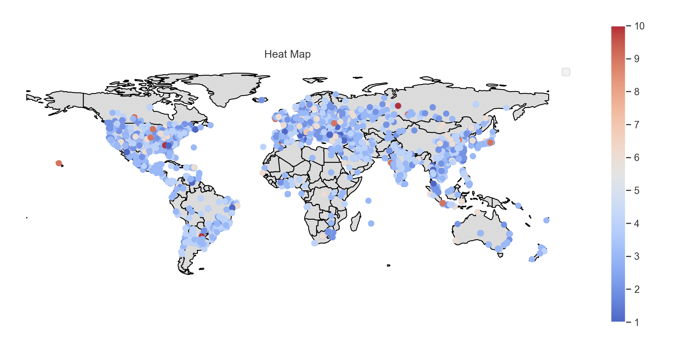

Interestingly, the strong regions of reliability are found in the US, with areas in Russia experiencing overall exhibiting the largest reliability scores.

Figure 4.2: Geo Heatmap of Risk

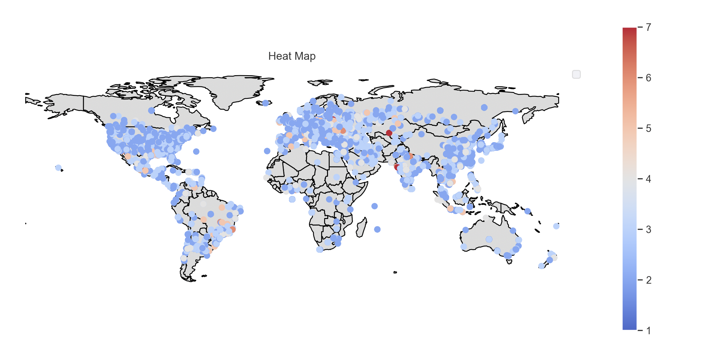

It appears that there are pockets of high-risk areas in Eastern Europe, South-East Asia as well South America. But in aggregate, there is not one singular area that can be visually deemed as high risk.

Figure 4.3: Geo Heatmap of X

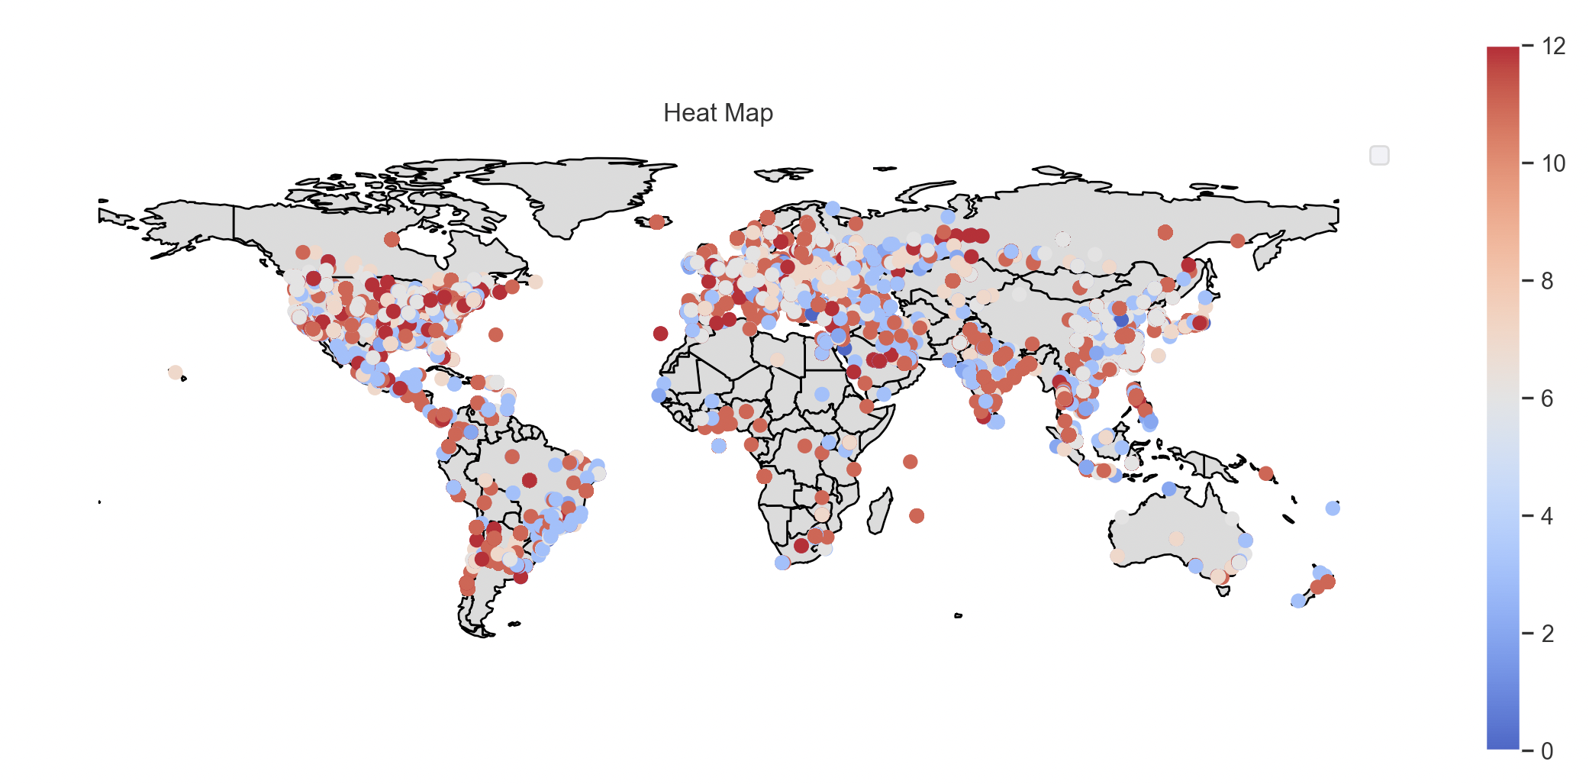

Although the colors appear more austere, the geo heatmap of X paints a similar story to risk. Specifically, it demonstrates that all geographic areas, at least visually, present an equal cyber security threat.

Figure 4.4: Stacked Bar Chart of Reliability

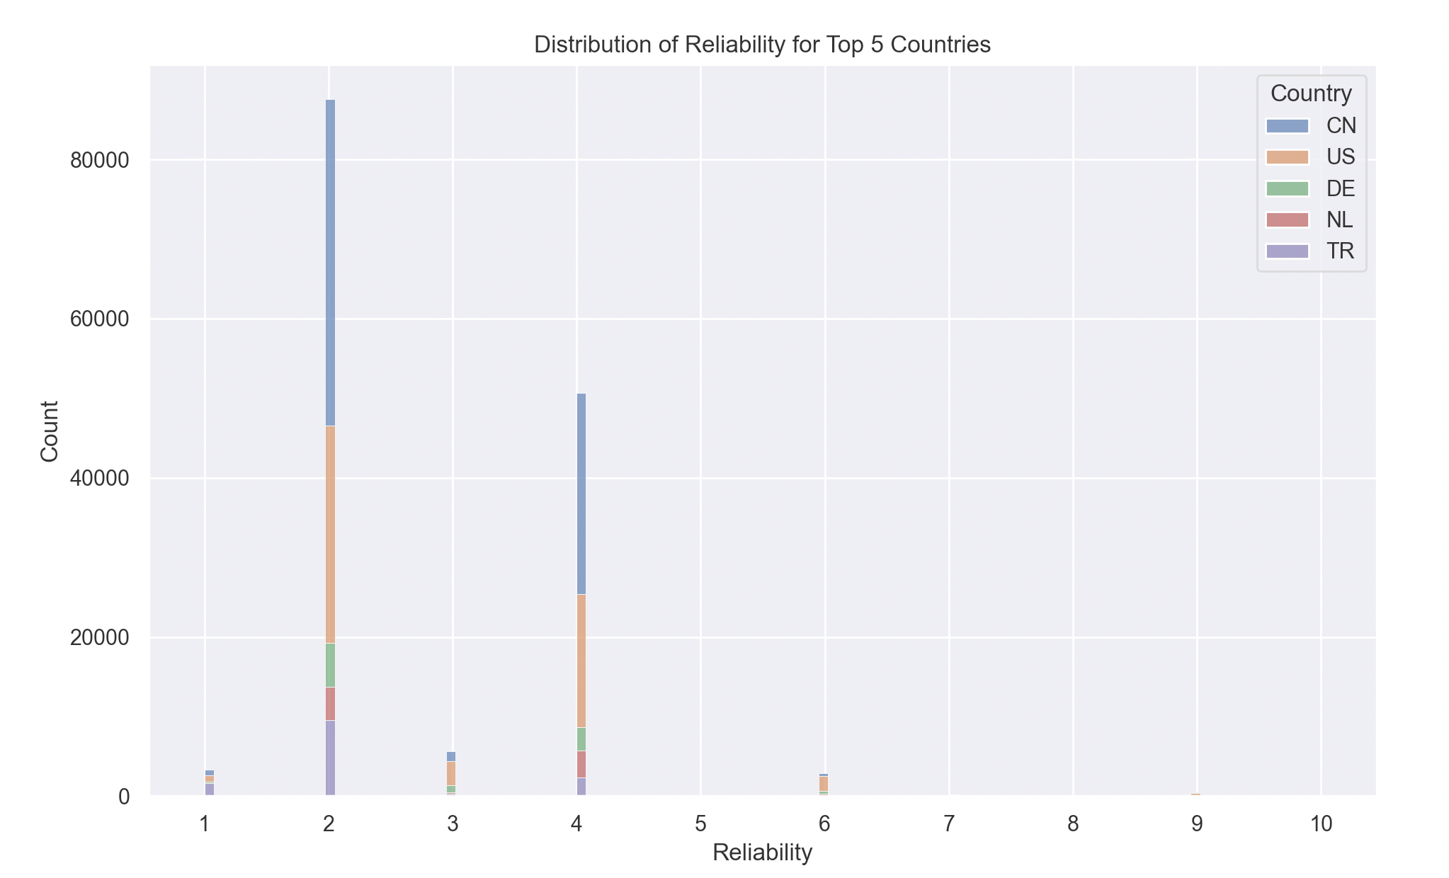

Figure 4.5: Stacked Bar Chart of Risk

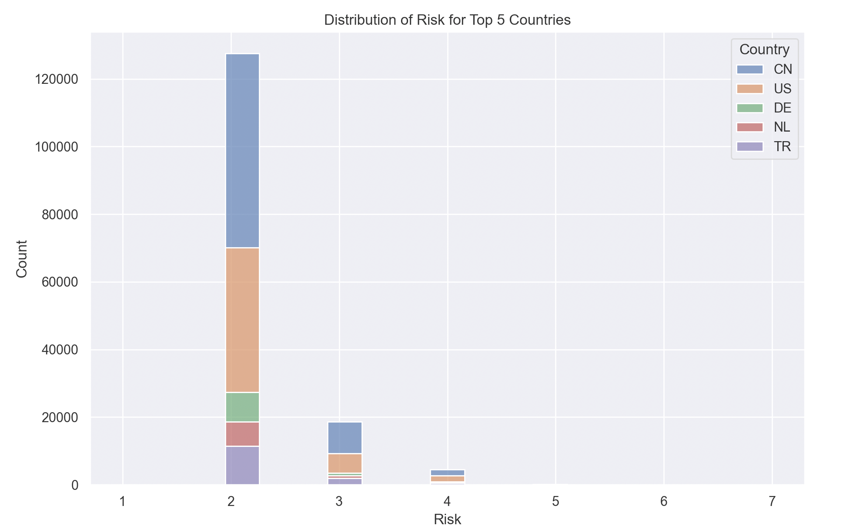

Both the visualisations of Risk and Reliability paint a similar story, that most countries are proportionately equal in their ratings of these two metrics.

Figure 4.6: Stacked Bar Chart of X Score for Top 5 Countries

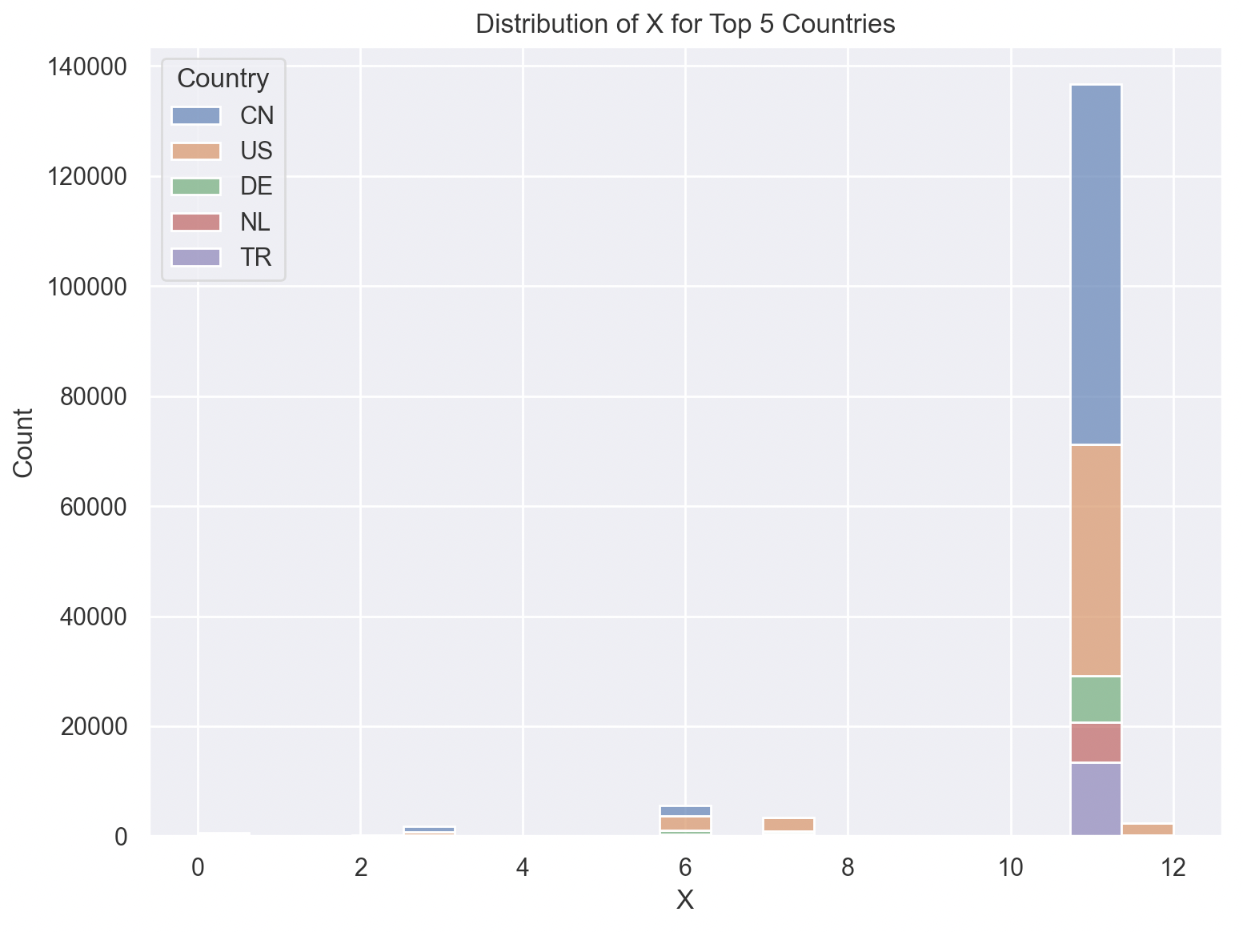

For the US, it appears they mark lower on the X score relative to the other 5 countries. TR, interestingly, is strongly concentrated at the upper end of this spectrum in relative terms

Figure 4.7 Count of IP Type for Top 5 Countries, unweighted

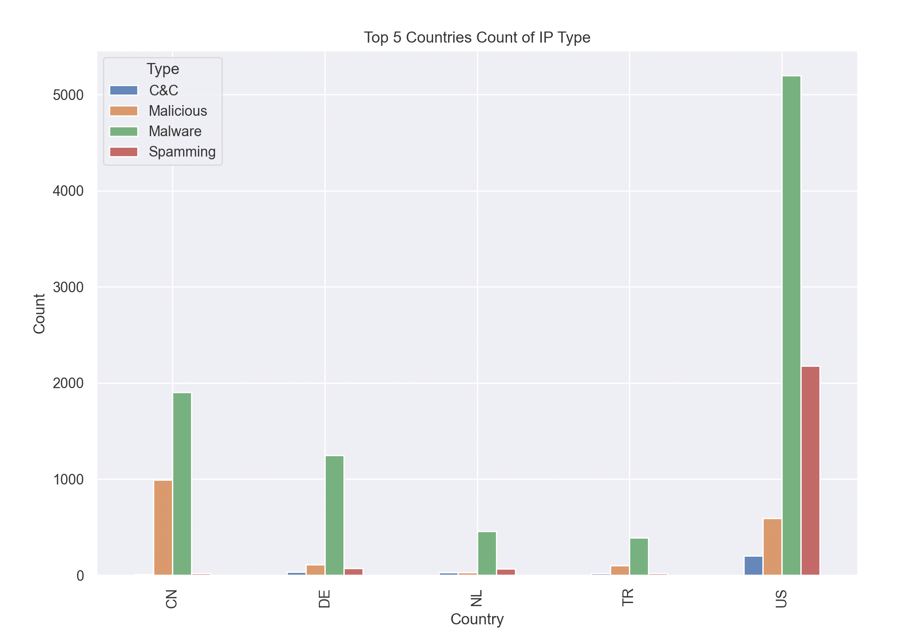

Initially it appears that the US hosts both the highest amount of Malware and Spamming nodes. However, as the location of IP addresses is dominated by the US and China, it would be incorrect to assume that since they have a large count of malicious IP Types, they should be considered in aggregate a country source of threat. Instead, it may be driven by the large volume of IP addresses located there.

To not distort the analysis, each score is weighted by the number of observations from each country.

$$weighted count= \frac{Count of IP Type}{Count of Country}$$

Figure 4.8 Count of IP Type for Top 5 Countries, weighted by size

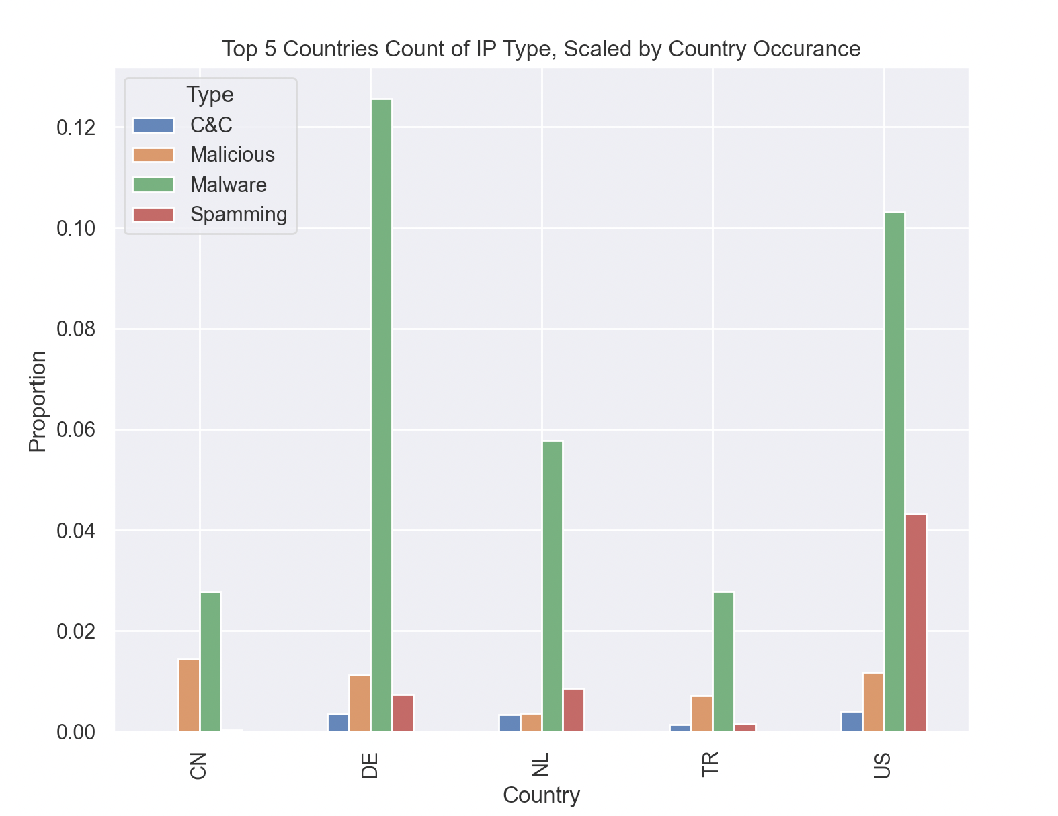

Comments: We see that after weighting by size, the picture dramatically changes. For instance, Germany, on a proportional basis, has the highest amount of Malware nodes.

Linear Regressions

As it appears difficult to draw any discernible conclusions from the prior visualisations, this next part of the analysis employs regression techniques to quantify whether geographic location has an impact on the associated threat of an IP address.

For all regression models, I have limited the number of countries considered to the top ten most frequently appearing countries (Germany, France, Great Britian, India, Russia, Netherlands, Taiwan, US, Turkey, and China). Secondly, for all regressions, the omitted variable is China to avoid the issue of multicollinearity.

Utilising the three numerical variables of Risk, Reliability and X score respectively, I employed a linear regression model to see if geographical position was associated with an increase or decrease in these three metrics.

Specifically, these numeric scores were regressed on dummy variables that indicate whether or not an IP address is located in one of these countries. The specification looks like so:

$$y_{i}=β_{0}+\sum_{i=1}^{C}{{β_{i}D}_{i}^{C}}+ε_{i}$$

Where:

$$y_{i}=risk, reliability, X score of observation i$$

$$D_{i}^{C}=\left\{\begin{aligned}1 if observation i is from country C \\ 0 if otherwise\end{aligned}\right.$$

Visulations, which display the coefficient estimate on the y axis and the p-value as the label, are shown below:

Figure 4.9 Coefficients and P-values for Risk Regression

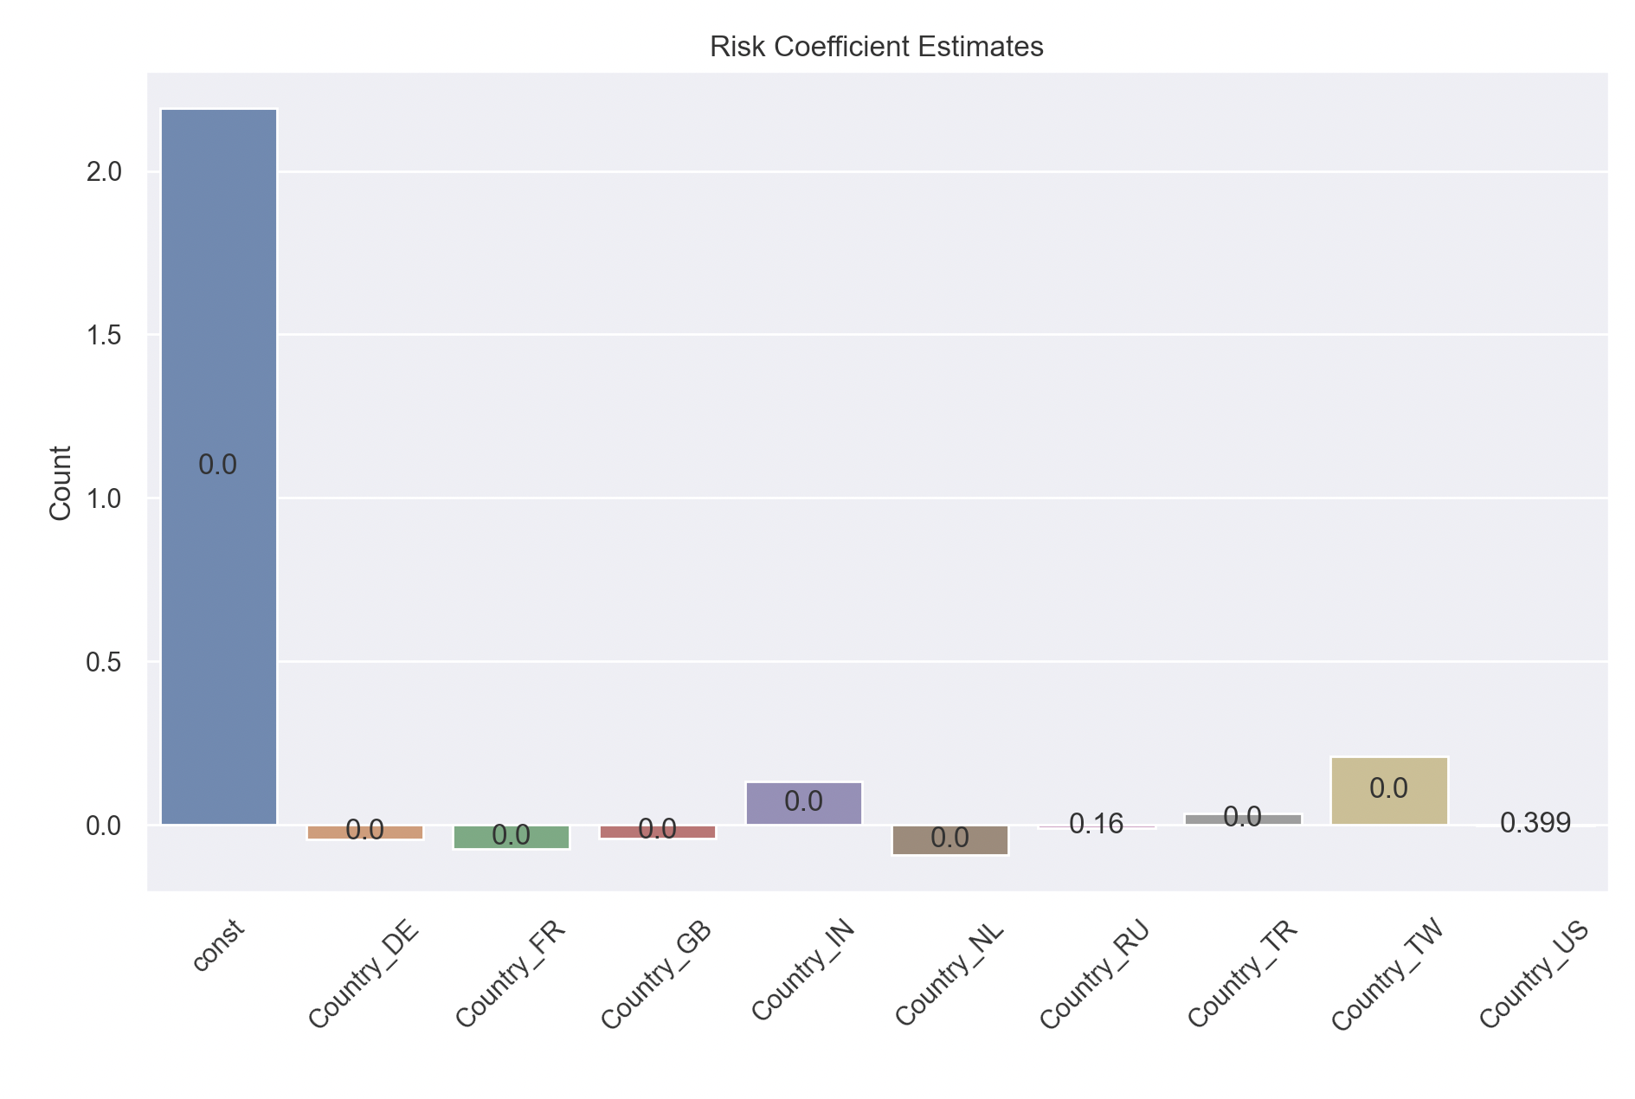

Figure 4.10 Coefficients and P-values for Reliability Regression

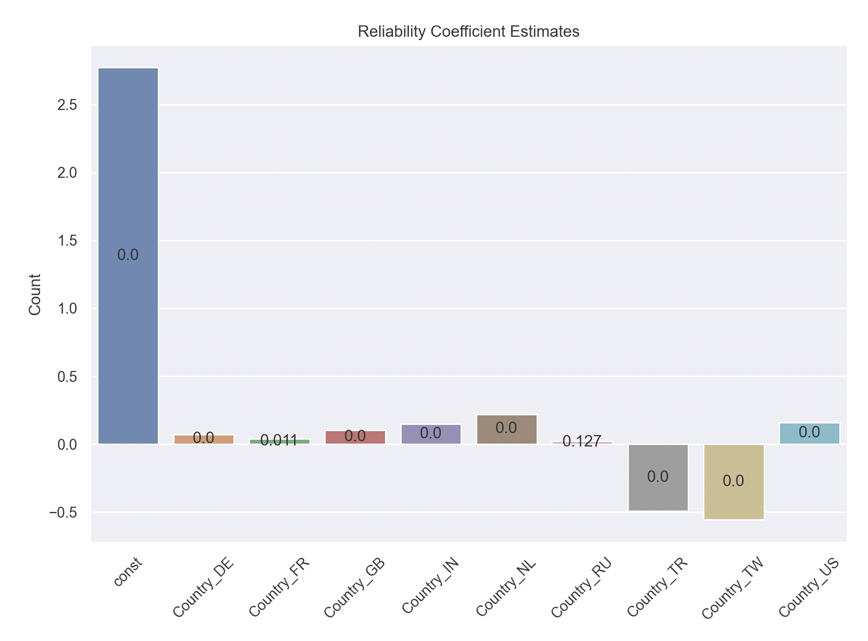

Figure 4.11 Coefficients and P-values for X Score Regression

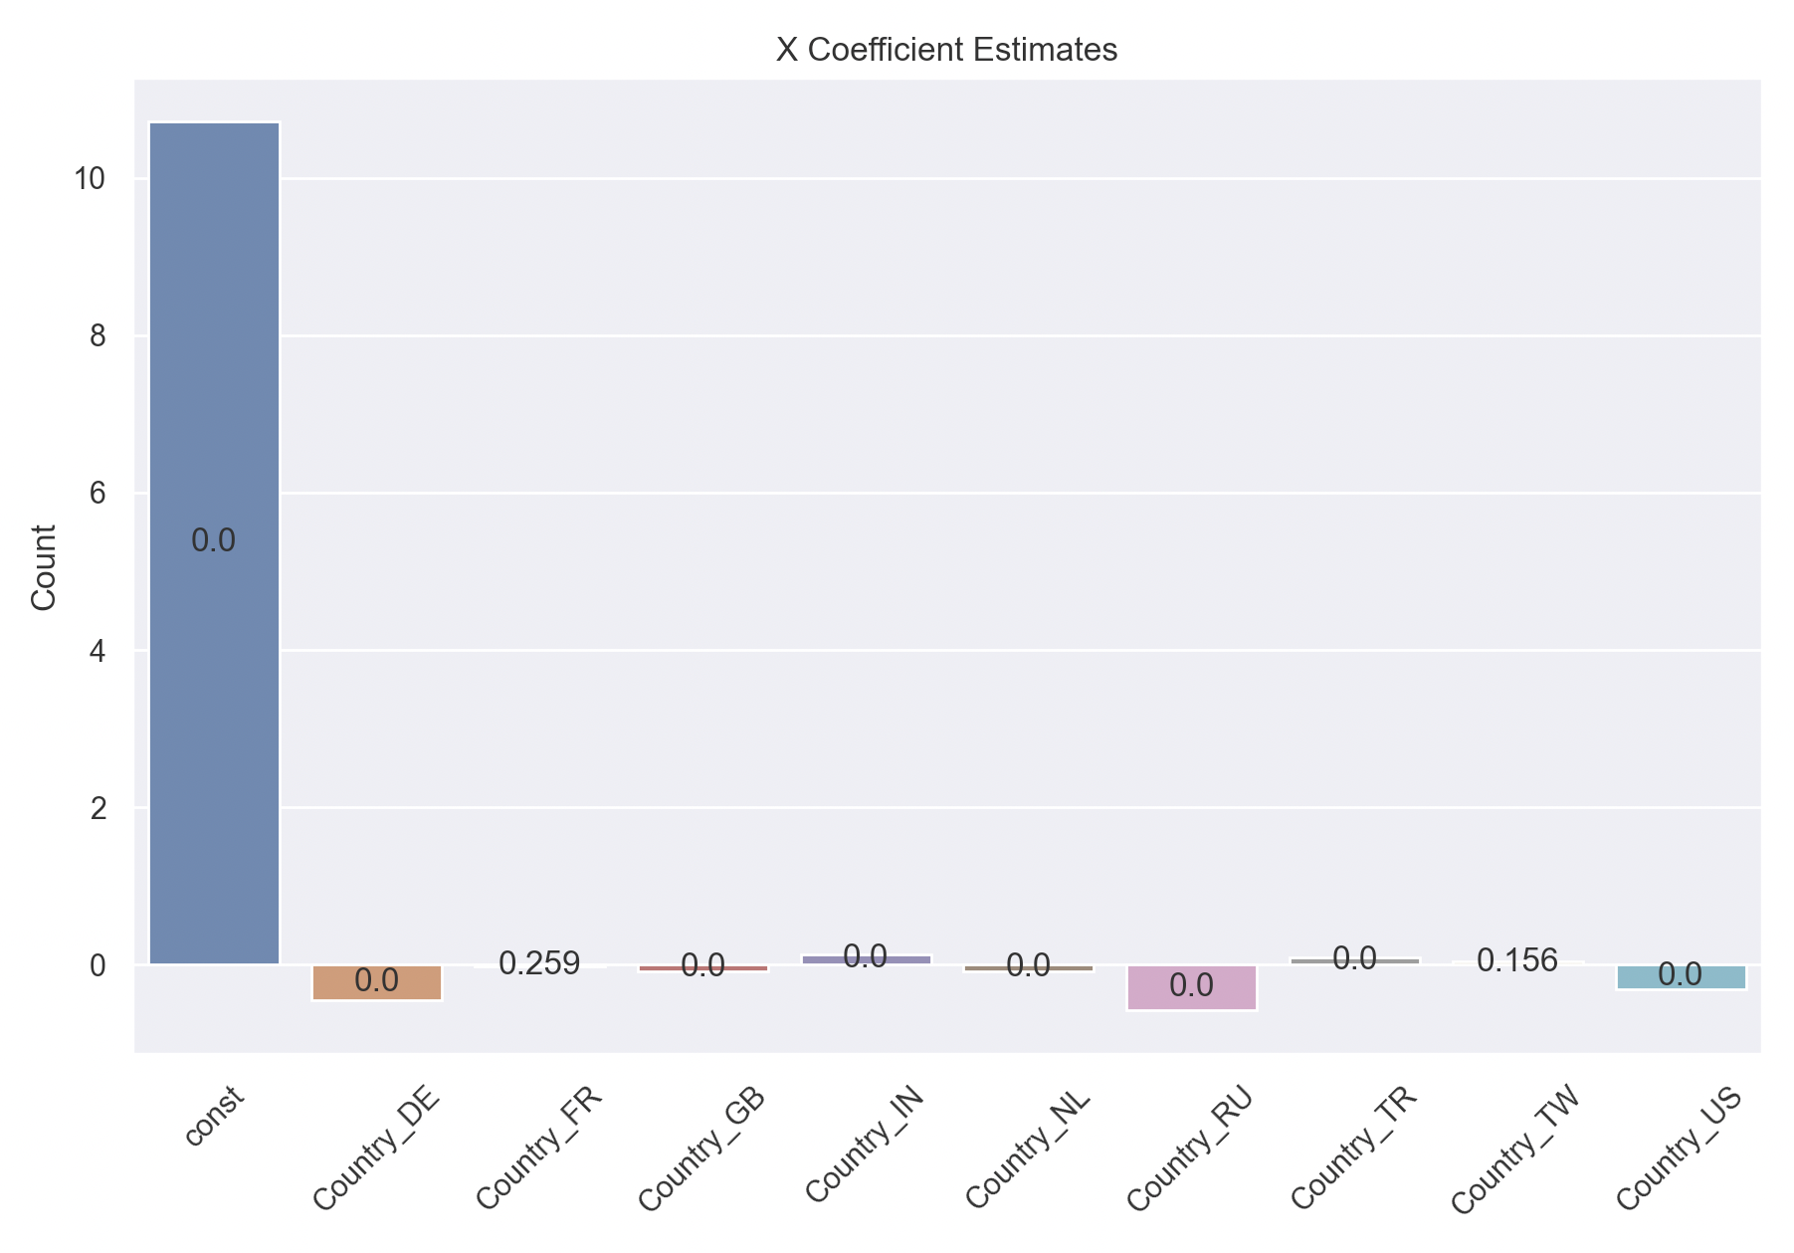

Comments:

The coefficients in the Risk regression demonstrate, as an example, that relative to China, Taiwan registered IP addresses are associated with a significant level of more risk, all else constant. Interestingly the South East Asian countries have statistically negative coefficients in the reliability regression. The inference could be that data from these locations is sparse and thus greater care should be taken when handling requests from these locations.

Linear Probability Model

Thus far, the ‘type’ categorical variable has been omitted from any quantitative analysis. In an effort to incorporate it, I created a binary indicator variable looking to capture whether a node was malicious or not. Specifically, I labelled the IP address as “0” if the variable was of IP Type “Scanning Host” and 1 otherwise.

This allows the performance of a linear probability linear model using the battery of aforementioned country dummy variable.

$$p_{i}=β_{0}+\sum_{i=1}^{C}{{β_{i}D}_{i}^{C}}+ε_{i}$$

Where:

$$p_{i}=\left\{\begin{aligned}1 if observation i is threat \\ 0 if otherwise\end{aligned}\right.$$

$$D_{i}^{C}=\left\{\begin{aligned}1 if observation i is from country C \\ 0 if otherwise\end{aligned}\right.$$

The outcome of the regression is illustrated below:

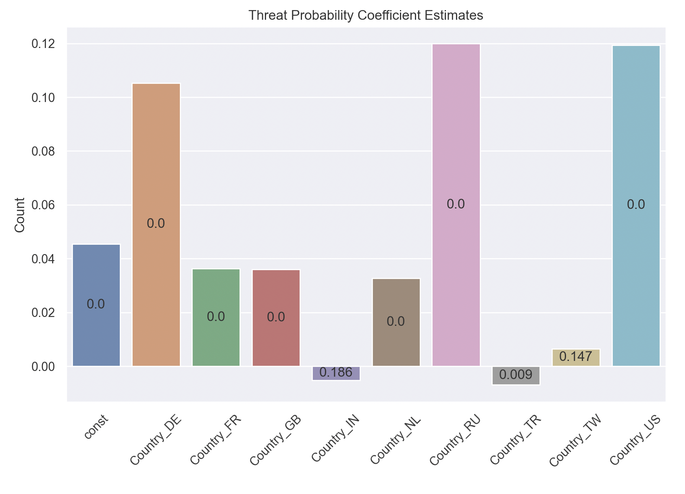

Comments: Paralleling the graphical analysis preformed earlier, we that all else constant, Germany has a 0.11 higher percentage point change of being considered a threat relative to a Chinese IP address. All coefficients, except Taiwan’s and India’s, are significant at the 5% confidence level, with US and Russian nodes representing a significantly larger threat than China.

**Conclusions: Present your final conclusions on the basis of the Page 3 of 5 analysis completed. For example: if using the AlienVault IP data and you were setting up a website, how would your analysis inform the security of your website? Is there further analysis which would be interesting to complete?**

To conclude, this analysis has sought to answer whether or not geographic location of an IP address serves as an indicator of its threat level.

This analysis utilised the AlienVault IP data set to answer this question. This data was well suited for this analysis. Firstly, its granular location, including a longitude and latitude for each IP address, allows for the construction of geographical heat maps.



From these graphics, there appear no discernible association between location and risk, other than pockets of high risk areas in Eastern Europe, South-East Asia as well South America.



As the key indicators of Risk and Reliability do not possess a great deal of variance, the analysis then focused its attention to see if geographic location, visually, demonstrated to have an association with IP type.

This analysis has the added benefit that observations are weighted by their occurrence in the dataset. For instance, we would be alarmed if China or the US had a high count of malicious IP types. However, given that they are the location of almost 50% of all IP addresses analysed this may be expected.

Although the visual analysis offered a graphical overview of the relationship between IP address and threat, it is difficult to detract any quantifiable association. To address this, linear regression models were employed, using IP country location as regressors. This illustrated that indeed, risk, reliability and X score are related to the country at which the IP address was from.

Further, IP addresses were categorised into threat and non-threat based upon IP Type, allowing the performance of a linear probabilistic regression model.



We see that all else constant, a Russian, US, or Germany IP address should be handled with greater care.

In summary, as a creator of a website, this research serves as a powerful reminder of what geographic location can tell us about Cyber security threats. I would personally collect geographic information from the user prior to their engagement with the website. If they are based in a country considered to be of high risk, then their privileges or access to the parts of the site may be restricted. This data should be monitored on an ongoing basis, with any significant changes to the results of the regression analysis driving cyber policy on the website. For instance, countries such as the US could be flagged as a threat, particularly if the site is susceptible to spamming nodes. Further, this data has highlighted the gaps in reliability scores, particularly in south east Asian countries. As a result, the emphasis on accurate data collection is stronger there, and the site can work to ensure that any requests from this region are handled with greater caution.